Catalase Enzyme Reaction Student Experiment - Eden Tomes

# Research Question:

How does increasing the volume of catalase solution (representing different enzyme concentrations) affect the rate of oxygen gas production when reacting with a constant volume and concentration of hydrogen peroxide?

# Rationale:

Cells, the fundamental units of life, depend on a multitude of biochemical reactions for survival and function, collectively known as metabolism (*Biology LibreTexts*, 2016). Many of these essential reactions would occur too slowly to sustain life without biological catalysts called enzymes (*Cooper*, 2000). Enzymes, primarily proteins, accelerate reaction rates by lowering the activation energy. They achieve this by binding to specific reactant molecules, or substrates, at a region called the active site, facilitating their conversion into products (*Robinson*, 2015).

Catalase is a crucial enzyme found in nearly all aerobic organisms, playing a vital protective role. It catalyses the decomposition of hydrogen peroxide (H₂O₂), a toxic byproduct of cellular metabolism, into harmless water (H₂O) and oxygen (O₂) (*Zamocky et al.*, 2008). This detoxification prevents oxidative damage to cellular components, a key aspect of how cells maintain homeostasis (*Nandi*, 2019).

The rate of enzyme-catalysed reactions is influenced by factors such as temperature, pH, substrate concentration, and enzyme concentration (*Robinson*, 2015). While a previous experiment explored temperature effects, this investigation focuses on how varying enzyme concentration impacts reaction rates. According to established enzyme kinetics, when substrate is abundant, the initial reaction rate is directly proportional to the enzyme concentration (*Aebi*, 1984). This is because more enzyme molecules mean more active sites are available to process the substrate, leading to faster product formation (*Robinson*, 2015).

This experiment aims to systematically investigate how altering the volume of catalase solution, thereby changing its effective concentration, affects the initial rate of oxygen production from hydrogen peroxide decomposition. By keeping substrate concentration, volume, and temperature constant, the study will isolate the influence of enzyme quantity on reaction rate. This will provide insight into how cells can regulate metabolic pathways by controlling enzyme availability.

# Methodology:

## Original Experiment

The original experiment investigated enzyme activity by reacting 1mL of stock catalase solution (yeast) with a set volume of hydrogen peroxide (10mL) in a reaction chamber. The chamber is submerged in a room-temperature water bath. Oxygen gas, the product of the reaction, is collected over water in an inverted measuring cylinder, and its volume is recorded at regular time intervals (every 30 seconds for 5 minutes) to determine the rate of reaction.

## Modifications

The original experimental design was modified to specifically address the research question concerning the effect of enzyme concentration on reaction rate. These modifications involved refinement for improved data quality and redirection to investigate the chosen variable.

The experimental procedure was refined to enhance the reliability of the collected data by conducting three independent trials for each of the tested volumes of catalase solution (1mL, 2mL, and 4mL). This replication improves the precision of the results by allowing for the calculation of mean oxygen production volumes and standard deviations. Averaging the outcomes from multiple trials helps to minimize the impact of random errors, such as slight variations in measurement or inconsistencies in bubble collection, thereby providing a more consistent and trustworthy dataset for each enzyme concentration.

The experiment was redirected from its original focus to directly investigate the new research. This was achieved through the systematic variation of the enzyme quantity. Instead of using a single volume, three different volumes of catalase solution were tested: 1mL (as a baseline, identical to the original method), 2mL, and 4mL. Since the stock catalase solution's concentration is constant, altering its volume directly changes the total amount of enzyme, and thus the effective enzyme concentration in the reaction mixture.

## Safety & Ethical Considerations

|  |  |  |
| --- | --- | --- |
| **Hazard** | **Identified Risk(s)** | **Control Measure(s)** |
| Hydrogen Peroxide (H202) | * Skin irritation or mild chemical burns. * Eye irritation or damage. | * Wear safety goggles and a lab coat at all times. * Handle H2O2 with care to avoid spills. * If H2O2 contacts skin, rinse immediately with plenty of water |
| Glassware (test tubes, beakers) | * Cuts from breakage. | * Handle carefully and avoid excessive force. * Keep glassware away from the edge of the bench. * Dispose of any broken glassware in a designated broken glass bin. |
| Chemical Spills | * Slip hazard on the floor. * Contamination of the work area or equipment. | * Clean up any spills immediately with paper towels as per teacher instructions. * Work on a clear, uncluttered bench space. |

# 

# Processed Data + Calculations:

## Example Calculations

Figure 1 – Results Table: Volume of Oxygen Present After 300 Seconds  
(values are in mL and rounded to 2 decimal places)

|  |  |  |  |
| --- | --- | --- | --- |
|  | **1mL Catalase** | **2mL Catalase** | **4mL Catalase** |
| **Trial 1** | 4.00 | 0.70 | 11.00 |
| **Trial 2** | 3.00 | 5.00 | 8.50 |
| **Trial 3** | 0.70 | 5.00 | 4.50 |
| **Mean** | 2.57 | 3.57 | 8.00 |
| **Std. Deviation** | 1.38 | 2.03 | 2.68 |
| **Std. Error** | 0.80 | 1.17 | 1.55 |
| **Upper Limit** | 5.33 | 7.62 | 13.35 |
| **Lower Limit** | 0.00 | 0.00 | 2.65 |

Figure 2 – Column Graph:

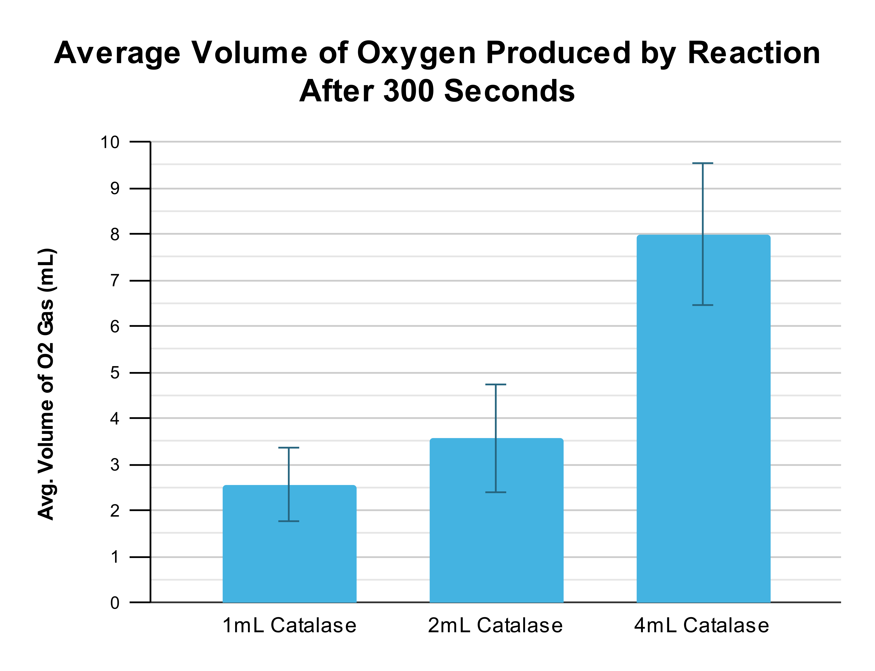

Figure 3 – Line Graph:

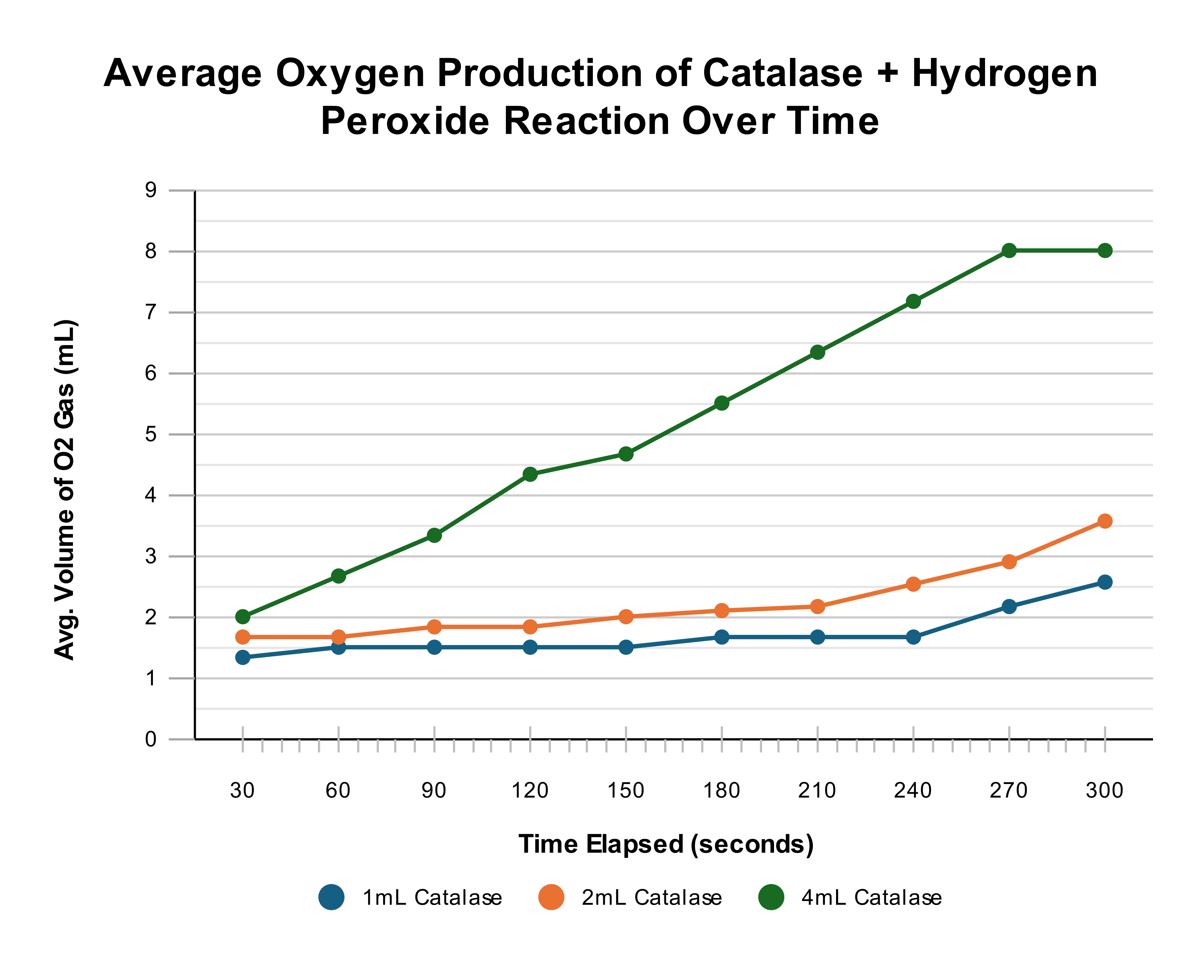

# Analysis of Evidence:

The experimental data collected indicates a relationship between the volume of catalase solution used and the amount of oxygen gas produced. As shown in Figure 1, the mean volume of oxygen produced after 300 seconds increased with increasing volumes of catalase solution. Specifically, the 1mL catalase condition yielded a mean of 2.57 mL of O₂, the 2mL condition produced a mean of 3.57 mL, and the 4mL condition resulted in a mean of 8.00 mL of O₂. This general trend is visually represented in the column graph (Figure 2), where the height of the bars increases with catalase volume.

The line graph (Figure 3), plotting oxygen volume over time for each catalase concentration, would be expected to illustrate the rate of reaction. A steeper initial slope on this graph would correspond to a faster rate of oxygen production. Based on the final mean volumes, it is anticipated that the 4mL catalase condition exhibited the fastest initial reaction rate, followed by the 2mL condition, and then the 1mL condition, though the graph itself would provide more direct evidence of these rates over the 5-minute period.

However, there was considerable variability within the trials for each enzyme volume, as highlighted by the standard deviations presented in Figure 1: 1.38 mL for the 1mL catalase trials, 2.03 mL for the 2mL trials, and 2.68 mL for the 4mL trials. For example, Trial 3 for 1mL catalase (0.70 mL) was substantially lower than Trial 1 (4.00 mL). Similarly, for the 2mL catalase, Trial 1 (0.70 mL) was markedly different from Trials 2 and 3 (both 5.00 mL). The 4mL catalase condition also demonstrated a spread, with Trial 3 (4.50 mL) being less than half of Trial 1 (11.00 mL). This degree of variation suggests potential inconsistencies or the influence of random errors during the experimental procedure.

# Evaluation:

## Limitations Of Evidence

Outlines limitations to data

## Sources Of Error Affecting Reliability

Explanation of why the experiment does not produce consistent outcomes

Random Errors (Impacting Precision): Several potential random errors likely contributed to the observed variability between trials within the same enzyme concentration group:

* Inconsistent timing of reaction initiation and submersion: The instruction to "IMMEDIATELY stopper the reaction chamber tightly, submerge it" allows for human variability. Slight differences in the time taken to seal the chamber and place it in the water bath could lead to varying amounts of initial gas escaping before collection commenced, or a delay in the reaction reaching the controlled temperature. This would randomly affect the volume of oxygen collected in each trial.
* Variability in bubble collection efficiency: Ensuring that all oxygen bubbles produced were channelled into the inverted measuring cylinder could have been inconsistent. Small variations in the positioning of the delivery tube, or the occasional formation of bubbles that adhered to the reaction chamber or tubing rather than entering the cylinder, would lead to random underestimations of gas volume. The wide range in results for the 1mL condition (0.70 mL to 4.00 mL) and the 4mL condition (4.50 mL to 11.00 mL) strongly suggests such inconsistencies.
* Subjectivity in reading gas volume: Reading the gas level in the graduated cylinder, especially if the water surface was disturbed by continuous bubbling or if parallax errors occurred, could introduce small, random inaccuracies in volume measurements.
* Homogeneity of catalase (yeast) solution: If the stock yeast solution was not perfectly homogenous or not mixed thoroughly before each aliquot was drawn, the actual number of yeast cells (and thus the amount of catalase enzyme) in the measured 1mL, 2mL, or 4mL portions could have varied slightly between trials. This would introduce random fluctuations in the effective enzyme concentration for nominally identical conditions.

These random errors reduce the precision of the experiment, making it difficult to confidently discern the true effect of enzyme volume from the inherent "noise" in the data. The large spread of results for each condition highlights this low reliability in terms of precision.

Systematic Errors (Impacting Accuracy): While the primary issue appears to be precision, potential systematic errors could have affected the accuracy of the results, causing them to consistently deviate from the true values:

* Calibration of measuring equipment: If the pipettes used to measure the catalase solution and hydrogen peroxide, or the measuring cylinder for gas collection, were not accurately calibrated, all volume measurements would be systematically higher or lower than the true volumes.
* Degradation of hydrogen peroxide stock: Hydrogen peroxide can decompose over time. If the solution used was not fresh or its concentration was lower than stated, the overall reaction rates and oxygen yields would be systematically lower across all trials than theoretically possible.
* Dissolution of oxygen in water: Some of the oxygen produced by the reaction would have dissolved into the water used for collection in the measuring cylinder, particularly during the initial stages before the water became saturated with oxygen. This would lead to a systematic underestimation of the actual volume of gaseous oxygen produced. The amount dissolved would be consistent under the same temperature conditions but would still mean the measured gas volume is not the total oxygen produced.

## Sources Of Error Affecting Validity

Explanation of why the experiment does not measure the most appropriate data

* Substrate Depletion at Higher Enzyme Concentrations: The rationale correctly states that reaction rate is proportional to enzyme concentration when the substrate is abundant. However, at the highest enzyme volume (4mL), the 10mL of hydrogen peroxide might have become a limiting reactant before the 5-minute observation period concluded. If the substrate was significantly depleted, the rate of oxygen production would slow down or stop, not due to the enzyme characteristics, but due to a lack of H₂O₂. This would mean the total oxygen collected at 300 seconds for the 4mL condition might not accurately reflect a rate solely dependent on enzyme concentration throughout the entire period, potentially underrepresenting the initial rate difference compared to lower enzyme volumes. Analysis of Figure 3 (the line graph of O₂ production over time) would be crucial to identify if such plateauing occurred.
* Confounding Variable of Total Reaction Volume: The methodology involved adding 1mL, 2mL, or 4mL of catalase solution to a constant 10mL of H₂O₂. This resulted in different total reaction volumes (11mL, 12mL, and 14mL, respectively). Consequently, the initial concentration of the substrate (H₂O₂) was slightly different for each condition, being most diluted in the 4mL catalase setup. While the amount of enzyme increased as intended, this slight variation in initial substrate concentration is a confounding variable. A more valid design would keep the total reaction volume constant (e.g., by adding a buffer or distilled water) to ensure the H₂O₂ concentration is identical across all tested enzyme levels.
* Measurement of Total Product vs. Initial Reaction Rate: The research question focuses on the "rate of oxygen gas production." While the total volume of oxygen collected after a fixed time (300 seconds) provides an average rate, enzyme kinetics studies typically emphasize the initial reaction rate (the rate during the early phase when substrate is not limiting and product inhibition is minimal). If conclusions are solely based on the final oxygen volumes (Figure 1 and Figure 2) without a careful analysis of the initial slopes from the time-course data (Figure 3), the interpretation might not accurately address the nuances of reaction rates influenced by enzyme concentration. For example, if a reaction is very fast initially but then rapidly consumes substrate, its final yield might be similar to a slower, more sustained reaction over the 5-minute period.
* Range and Increments of Enzyme Volumes: The chosen volumes (1mL, 2mL, 4mL) did show an increasing trend in mean oxygen production. However, given the high variability, it is difficult to ascertain if this range was optimal or if the increments were ideal for clearly demonstrating the expected direct proportionality. The jump in mean oxygen production was more pronounced between 2mL and 4mL than between 1mL and 2mL, but the large standard errors make it difficult to draw firm conclusions about the linearity of the response.

## *Suggested Improvements & Extensions*

Explanation of ways to improve the experiment in order to address sources of error affecting validity and reliability

Suggests ways to increase the breath or scope of the investigation

Improvements to Current Methodology:

* Standardise Reaction Initiation and Temperature Equilibration: To improve precision by minimising variations in initial reaction conditions, all components (hydrogen peroxide and catalase solution) should be allowed to equilibrate to the water bath temperature (e.g., 30°C as per the original experiment's setup image) before mixing. A more controlled method for initiating the reaction, such as injecting the catalase solution into the submerged, sealed reaction chamber containing the hydrogen peroxide, could reduce gas loss and timing inconsistencies.
* Control Total Reaction Volume: To ensure the initial substrate (H₂O₂) concentration is identical across all enzyme conditions, thereby improving validity, the total reaction volume should be kept constant. For example, when using 1mL of catalase, 3mL of buffer or distilled water could be added. For 2mL of catalase, 2mL of buffer would be added, and for 4mL of catalase, no additional buffer would be needed if the target total volume with H₂O₂ was, for instance, 14mL.
* Enhance Gas Collection and Measurement: To improve precision in gas measurement, ensure the delivery tube is positioned deep within the measuring cylinder to prevent bubble escape. Using a gas syringe instead of collecting gas over water would eliminate the issue of oxygen dissolving and provide more accurate direct volume readings, improving both precision and accuracy.
* Increase Number of Trials and Replicates: Conducting more trials (e.g., 5 or more) for each enzyme concentration would provide a more reliable mean and reduce the impact of individual anomalous results, thereby improving the statistical power to detect significant differences.
* Focus on Initial Reaction Rates: To more accurately address the effect of enzyme concentration on reaction rate as per enzyme kinetics principles (improving validity), data should be collected at shorter intervals (e.g., every 10-15 seconds) especially during the first minute of the reaction. The initial linear slope of the oxygen volume vs. time graph should then be calculated and used as the measure of reaction rate.
* Ensure Homogeneity of Enzyme Solution: Thoroughly mix the stock yeast solution before each sample is taken to ensure a consistent enzyme concentration is being used for each trial.

Possible Extensions:

* Investigate a Wider Range of Enzyme Concentrations: Extending the experiment to include more, and possibly smaller or larger, increments of enzyme concentrations could help to more clearly define the relationship between enzyme concentration and reaction rate, and to identify if/when the enzyme concentration itself becomes saturating or if substrate limitation occurs at higher concentrations.
* Determine the Effect of Substrate Concentration: A redirected experiment could investigate how varying the concentration of hydrogen peroxide affects the reaction rate while keeping the enzyme concentration constant. This would allow for a fuller exploration of enzyme kinetics.
* Study the Effect of pH or Inhibitors: Once the base experiment is reliable, it could be extended to investigate how other factors like pH or the presence of specific enzyme inhibitors affect catalase activity.

# Conclusion:

A

# Reference List:

* Aebi, H. (1984). Catalase in vitro. *Methods in Enzymology*, [online] 105, pp.121–126. doi:[https://doi.org/10.1016/s0076-6879(84)05016-3.](https://doi.org/10.1016/s0076-6879(84)05016-3)
* Biology LibreTexts. (2016). *1.16: Types of Biochemical Reactions*. [online] Available at: [https://bio.libretexts.org/Bookshelves/Introductory_and_General_Biology/Introductory_Biology_(CK-12)/01%3A_Introduction_to_Biology/1.16%3A_Types_of_Biochemical_Reactions.](https://bio.libretexts.org/Bookshelves/Introductory_and_General_Biology/Introductory_Biology_(CK-12)/01%3A_Introduction_to_Biology/1.16%3A_Types_of_Biochemical_Reactions)
* Cooper, G. (2000). *The Central Role of Enzymes as Biological Catalysts*. [online] National Library of Medicine. Available at: <https://www.ncbi.nlm.nih.gov/books/NBK9921/>.
* Nandi, A. (2019). Role of Catalase in Oxidative Stress- and Age-Associated Degenerative Diseases. *Oxidative Medicine and Cellular Longevity*, [online] 2019(9613090). doi:<https://doi.org/10.1155/2019/9613090>.
* Robinson, P. (2015). Enzymes: Principles and Biotechnological Applications. *Essays in Biochemistry*, [online] 59(1), pp.1–41. doi:[https://doi.org/10.1042/bse0590001.](https://doi.org/10.1042/bse0590001)
* Zamocky, M., Furtmüller, P.G. and Obinger, C. (2008). Evolution of Catalases from Bacteria to Humans. *Antioxidants & Redox Signaling*, [online] 10(9), pp.1527–1548. doi:[https://doi.org/10.1089/ars.2008.2046.](https://doi.org/10.1089/ars.2008.2046)

# Appendix:

## Raw Data

A